333 Wacker Drive

The year was 1983, Chicago’s architecture was booming yet consisted mainly of tall box high rises and skyscrapers. Suddenly, Chicago’s architecture was changed forever with the construction of 333 Wacker Drive, Chicago’s first postmodern skyscraper. A title not easy to acquire, 333 Wacker Drive obtained this honor due to the buildings immense innovations in construction and style. Featuring a shape unlike any other, the building called for only the best in design, engineering, and materials before the construction could commence. Along with the physical aspects of the building, the new style commanded change from the existing fashion of architecture. This new style shattered the traditional glass box style of building and created something entirely new with multiple sections, angles, and shapes. With all aspects combined, 333 Wacker Drive changed Chicago’s Architecture forever by enriching it to a level never seen before. With the new standard for design the building created, every postmodern building constructed in Chicago afterward has faced 333 Wacker Drive in direct competition, yet there has not been a building created to this day that surpasses it in design and beauty.
The client for 333 Wacker Drive, the Urban Investment and Development Corporation, took a risk when they commissioned Kohn Pedersen Fox to design their building, as the firm was just established in 1976 in New York, New York. It would also be the firm’s first big building, as it would be 36 stories tall and constructed on a triangular lot just outside the already established loop area. Costing $115 million and taking four years to construct, (1979-1983) 333 Wacker Drive would be no small venture for either firm. Project underway, William Pedersen took control of the design team and began the creation of the building. His firm being in New York, Pedersen needed support from architects in Chicago to do the tasks he was unable due to at his location. For this job, he hired associate architects Perkins and Will, who would handle all city related issues of the construction.
When presented with the triangular lot, Pedersen knew he did not want to construct another building in the brutal style that so many Chicago buildings were already designed in. He also knew that with a lot in front of the river, the building would be afforded great exposure to the sky and the buildings across the river, as they would have an unobstructed view of the lot. With this realization, he designed the north side of the building to curve to compliment the curve of the Chicago River. This caused the building and river to run parallel with each other giving the building a certain harmony with nature.
Creating the curve would also turn 333 Wacker Drive into a giant (See figure 2)
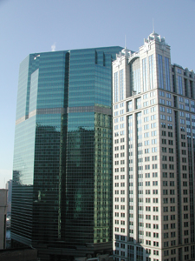
mirror, which reflected the river, the buildings across the river, and the clouds in the sky. After construction, it is said that some of the most beautiful scenes are be created by the reflections off the building and river when the sunlight is at the proper angle and the cloud coverage is light to moderate.
As Pedersen created the curve to create a harmony with the river, he also designed the south and east walls of the building to draw toward the intersection of Franklin and Lake, but then would connect them together with a southeastern facing wall, to create a harmony with the (See Figure 7)
loop section of downtown. This wall, which would create a triangle with the intersection, further established the triangular shape of the building. He also indented the southeastern wall in the center to create a v shaped channel down the middle of the buildings southeastern elevation to provide room for inside corner offices that added style to the building.
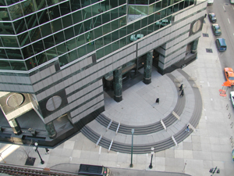
At the base of this southeastern wall lies the rear entrance to 333 Wacker Drive, serving people entering the building from the loop section of downtown. This entrance, the favorite of Pedersen, is especially important for the building as it the true connection the city, since the lot (See figure 6) the building is on is technically outside the loop section of downtown. While not the primary entrance, it is certainly the more functional and frequently used way to get into the building.
With concepts of how he would construct the front and back of the building, Pedersen now gained the ability to work on the fine details of the exterior appearance. As with every Kohn Pedersen Fox building, Pedersen’s would include a distinctive capital, tower and base. The
(See figure 2) capital, at the top level above the curved levels, acts as an office penthouse yielding the highest rates in the building, yet containing less square feet then other floors. For the capital and tower, Pedersen used double paned green tinted glass, which created the glass curtain wall that gave the building a stretched horizontal look that contrasted the extremely vertical Merchandise Mart across the river. To further extenuate the horizontality of 333 Wacker, Pedersen planned to attach continuous bullnose strips across the glass in six-foot segments. The designers also chose the green tint for the glass as they thought it would cause the glass to become more prismatic and crystalline as it rapped around the building, adding the effect of tautness.
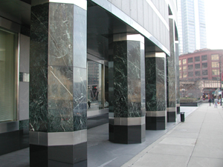
For the base section, the building was given octagonal Vermont marble columns at the corners and entrances of the building. These columns, consisting of green marble, black granite, and trimmed stainless steel, pay homage to the Merchandise Mart as its towers have a similar (See figure 3)
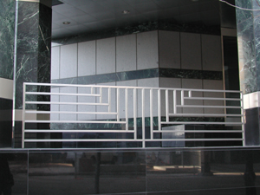
appearance. To finish off the base of the structure, Pedersen used stainless steel railings to close off areas that where not at street level, such as ramps and smoking areas. Designed to add decoration as well as purpose, the railings feature horizontal lines to stress the horizontality of the (See figure 4)
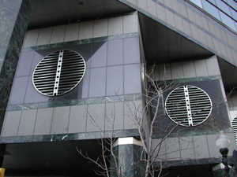
building along with a triangle to show the overall shape of the building. To offer a slight contrast to all of the horizontal lines, Pedersen chose to make the second level clean air intakes circular as to give them definition on the building. Also made of stainless steel, these vents provide 333 Wacker Drive with its
(See figure 5) primary source of clean air for the buildings ventilation system.
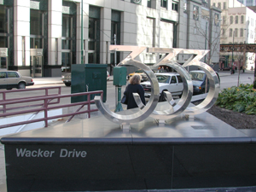
To add a finishing touch to the building, Pedersen designed a stainless steel address marker to sit at the northeast corner of the building. While all of these are still subtle additions to the building, these small details are what make the building so powerful (See figure 1)
and prominent in Chicago’s skyline.
With his exterior design complete, Pedersen moved on to planning the construction of the buildings steel skeleton load-bearing frame. In order to have the glass curtain wall exterior, the key factor for Pedersen in the design of the building, all weight was designed to go to the buildings core. While this allowed for a beautiful exterior, the inside of the building would be plagued by diagonal steel support beams for wind resistance that would go through areas where offices could have been had the beams not been there. As it was intended from the start to leave the interior floor design to the occupant, this would not cause major problems as the beams would be worked around or closed off when the interior offices were designed.
Once the design and construction was completed, people could begin to analyze the style in which 333 Wacker Drive was constructed. Since the building was the first postmodern architecture in Chicago, it redefined how we look at our current buildings, and then we were able to tell which aspects of each we like the most to put them into the next buildings we will construct.
One commonly unknown fact of 333 Wacker Drive is that Pedersen chose the Vermont marble and polished granite for the base of the building in an attempt to echo the robustness of the Rookery. He did this since the marble and granite are totally different in texture than the sheer glass wall, while also being richer in detail, a characteristic Pedersen saw in the Rookery’s design materials.
A more commonly seen aspect of the building is that many are quick to see it as just another glass box. Although it does share many characteristics with glass box architecture, such as a steel skeleton frame that carries the entire load of the building, it is far from being just another glass box.
Primarily, it defies the defining characteristic of glass box architecture; it is not a box in shape. While glass can be applied to walls that are not load bearing, a supporting structure must be constructed that is capable of holding the weight of the glass. This makes the design of the steel skeleton key to the construction of any glass-covered structure. This is especially true for 333 Wacker Drive, as the buildings shape requires steel support beams running diagonally in order for changes in wind to have no effect on the building. Therefore, 333 Wacker Drive was more difficult to construct because the load from the glass had to be distributed evenly on and oddly shaped structure. Nevertheless, the building was constructed and stands without difficulty, being perfectly stable despite its odd shape.
When Pedersen finished 333 Wacker Drive, he had one final request of the architect that builds next to his latest masterpiece, that the building is built in a masonry-clad style as to contrast the glass tower of his building. Surprisingly enough, his firm was commissioned to build that building also two years later in 1985. They were granted the designing rights of 225 West Wacker Drive and once again Perkins and Will would assist them.
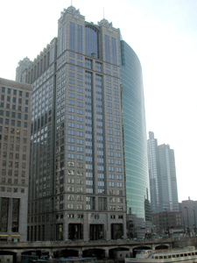
With construction beginning in 1985, Pedersen designed 225 West Wacker to be a 31-story office building in his wish of a masonry-clad exterior. To differ from the look of 333 Wacker Drive, Pedersen gave the building a more classical style of architecture that would more resemble a building form Chicago. Nevertheless, this did not stop him form including many (See figure 8)
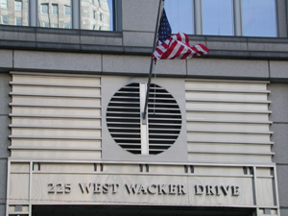
of the aspects of 333Wacker Drive into his newest building. The most noticeable, is that of the large circular clean air intake vent, that calls out to say the building is related to the one next to it, being 333 Wacker Drive. Other aspects of its cousin include horizontal line accents on the front and (See figure 9) around the sides of the building. Stainless steel is also frequently used to accent the building and add trim to its facade.
225 West Wacker is also linked to its surrounding buildings and structures such as the Merchandise Mart and Chicago River Bridge. The towers found on top the building though rectangular, resemble those found on the Mart. Metal bridges similar to those on the bridge then tie these towers together. With these contextual references, there is no doubt that Pedersen was attempting to link his work with the cities foundation that marks its culture. With the completion of 225 West Wacker Drive, Pedersen’s work was complete leaving behind a perfect balance of design between the two buildings
With such amazing characteristics, 333 Wacker Drive is without a doubt one of the finest buildings Chicago has to offer. With its stunning construction, that yields amazing beauty, attention to detail, and symmetry combined with its innovative style, which renews aspects of our past, brings in original design, and links us to other aspects of our culture, it is a building that will truly last forever. For all these reasons and more, 333 Wacker Drive is a building sure to always have a high place among my favorite buildings and styles of architecture.

Sources Consulted

- Zukowsky, John and Saliga, Pauline The Sky’s The limit: A Century of Chicago Skyscrapers New York: Rizzoli International Publications, Inc., 1990

- Sharp, Robert V. and Jentsch, Carol ed. Chicago Architecture and Design, 1923-1993 New York: te Neues Publishing Company, 1993

- Hines Interests 225 West Wacker Information Book Chicago: Hines Interests Limited Partnership

- OPL 333 West Wacker Drive Chicago: Overseas Management, Inc

- Lend Lease Lend Lease’s Value Enhancement Fund IV and JBC Acquisition Development Fund I Acquire 333 West Wacker in Chicago Web Site. www.lendleaserei.com, 2000
- Newman, M.W. “333 Wacker rounds river with power” Chicago Sun Times 12th June 1983, page 22
- Unknown Author “Cornering the Loop” Progressive Architecture Oct. 1983
- KPF Projects 333 Wacker Drive Chicago, IL Web site. www.kpf.com/project1.html
- American Institute of Architects Chicago. AIA Guide to Chicago Orlando: American Institute of Architects Chicago., 1993

